
Company
Logotype

Cone Beam Computed Tomography- Report



Porur Dental X-rays & CBCT

Patient Name : Mr. Sathish Kumar | Date of Report : 01.08.2024
Age/ Gender : 41 years/ Male | Region of Interest : CBCT Sectional Mandible
Referring doctor: Jaya’s Dental clinic | Indication : Assessment of 45, 46
Clinical Notes: Nil
PATIENT INFORMATION

CBCT- Sectional Mandible provided
CBCT – IMAGE DETAILS

RADIOGRAPHIC INTERPRETATION

- The tooth 48 is horizontally placed and the crown of 48 appears to impinge on the distal surface of 47. The apical third of 48 lies in close proximity to the inferior alveolar nerve canal.
- There is no visible fracture line present in relation to 45 and 46.

RADIOGRAPHIC IMPRESSION

- Impacted tooth : 48

Kindly correlate with clinical findings


IMAGES FOR REFERENCE

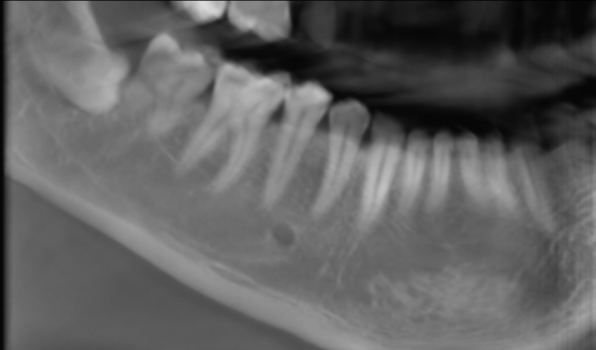

3-DIMENSIONAL VIEW
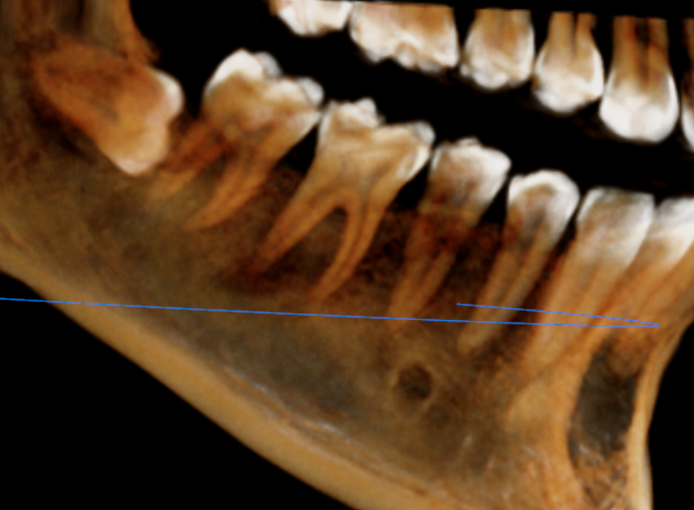

Coronal section of 45, 46 region
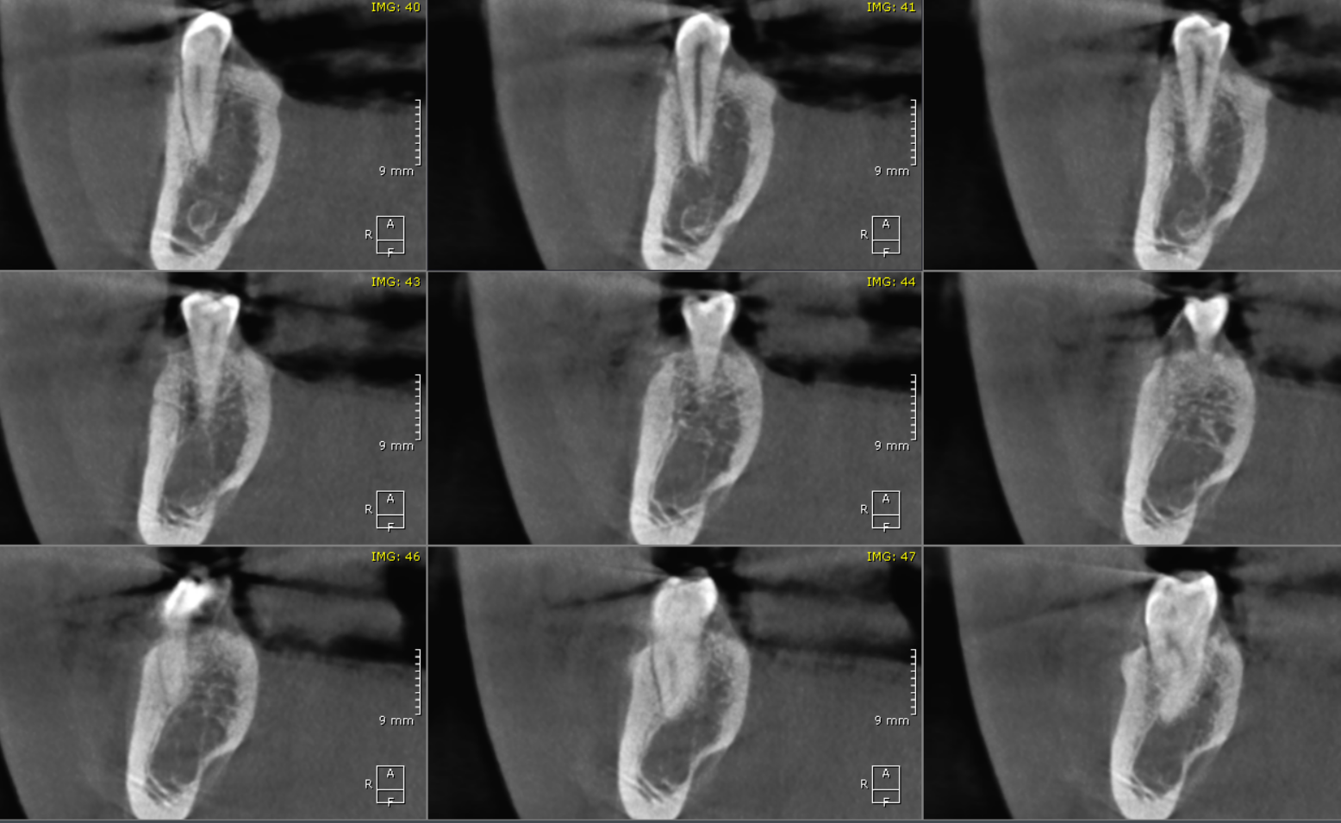

Sagittal section of 45, 46 region
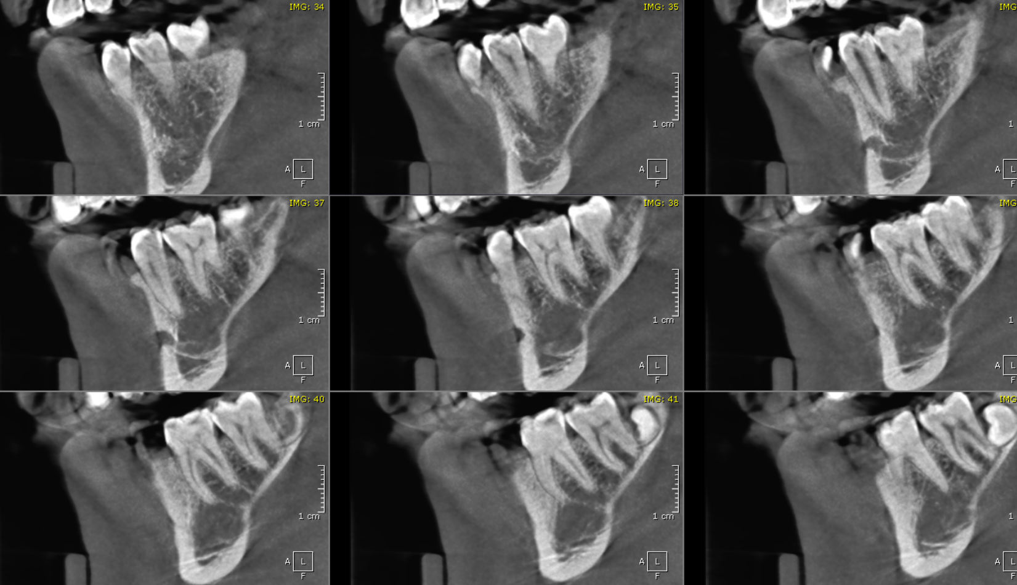

CROSS SECTIONAL VIEW

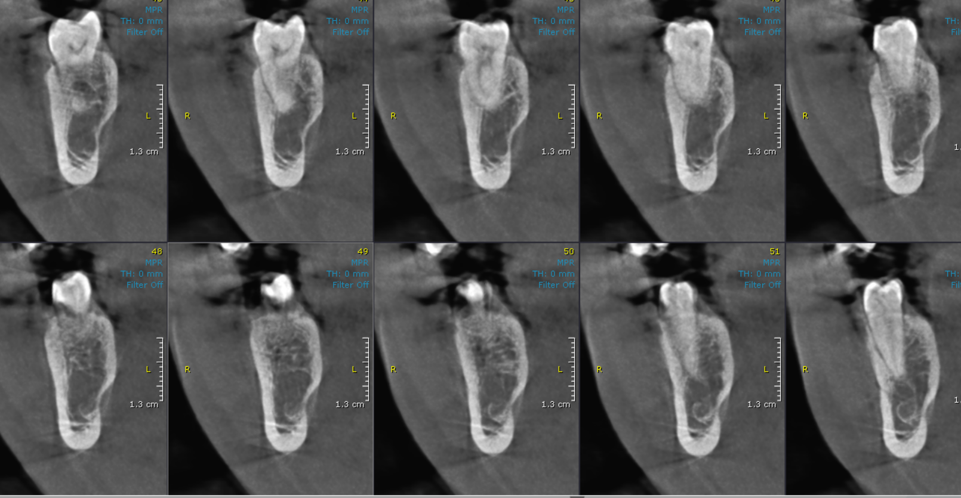

**** End of report ****

